Landing Page

Definition
# Source: AI Source: Provided by: [Data Path: Persons Table -> ID Column: 1, Name_En Column: Motasem Essam] -> From: [Chatgpt (GPT‑5 Mini)] on [2/12/2026]
A Landing Page is a special web page designed for one specific goal, usually related to marketing or promotion—like getting visitors to sign up, buy, download, or register.

Simple Definition
# Source: AI Source: Provided by: [Data Path: Persons Table -> ID Column: 1, Name_En Column: Motasem Essam] -> From: [Chatgpt (GPT‑5 Mini)] on [2/12/2026]
Landing Page = a focused page created to make visitors take one action.

Common Goals of a Landing Page
# Source: AI Source: Provided by: [Data Path: Persons Table -> ID Column: 1, Name_En Column: Motasem Essam] -> From: [Chatgpt (GPT‑5 Mini)] on [2/12/2026]
- Sign up for a newsletter
- Buy a product or service
- Register for an event or course
- Download an app, ebook, or file
- Fill out a form (leads / inquiries)

What a Landing Page Usually Includes
# Source: AI Source: Provided by: [Data Path: Persons Table -> ID Column: 1, Name_En Column: Motasem Essam] -> From: [Chatgpt (GPT‑5 Mini)] on [2/12/2026]
- Clear headline – explains the offer quickly
- Short description – benefits or details
- Call-to-Action (CTA) – button like Sign Up, Buy Now, Get Started
- Images or videos – show the product/service
- Form (optional) – collect user info (name, email, etc.)
- Testimonials (optional) – build trust

Key Characteristics
# Source: AI Source: Provided by: [Data Path: Persons Table -> ID Column: 1, Name_En Column: Motasem Essam] -> From: [Chatgpt (GPT‑5 Mini)] on [2/12/2026]
- Focused on one goal only
- Simple design, few distractions
- Often used in ads, marketing, and campaigns
- Optimized for conversion (getting users to act)

Example
# Source: AI Source: Provided by: [Data Path: Persons Table -> ID Column: 1, Name_En Column: Motasem Essam] -> From: [Chatgpt (GPT‑5 Mini)] on [2/12/2026]
- A page for downloading a free ebook
- A product promotion page from an advertisement
- A course registration page

Difference Between Landing Page and Home Page
# Source: AI Source: Provided by: [Data Path: Persons Table -> ID Column: 1, Name_En Column: Motasem Essam] -> From: [Chatgpt (GPT‑5 Mini)] on [2/12/2026]
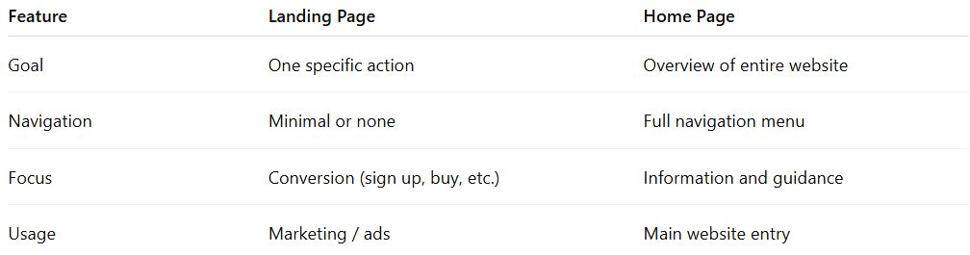
Feature | Landing Page | Home Page
Goal | One specific action | Overview of entire website
Navigation | Minimal or none | Full navigation menu
Focus | Conversion (sign up, buy, etc.) | Information and guidance
Usage | Marketing / ads | Main website entry

